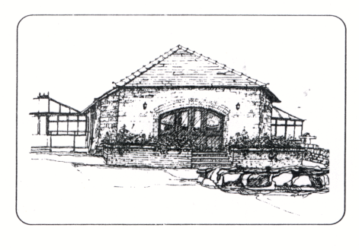
APPLICATION FORM – PERSONAL DETAILS
Date
Position applied for
Name | (Mr/Mrs/Ms/Miss/other)
DOB
Address

Telephone no’s

Qualifications/ Certificates

Attach cv if available

Employment History (Min 10 years) with gaps explained

Employer or Gap | Dates of employment  From mm/yy To mm/yy | Job Title / Responsibilities | Reason for leaving or explanation for gap

Significant Medical History (include back problems)

Relevant experience and other details to support your application.

Please give the Name and address of 2 referee’s. The first given must be your current or most recent employer. | 1. 2.

A full DBS check is required for this post. You will be asked to supply identification.

This post is exempt from the provisions of section 4(2) of the REHABILITATION OF OFFENDERS ACT 1974 by virtue of the REHABILITATION OF OFFENDERS ACT 1974 (EXCEPTIONS) ORDER 1975 (as amended).

Applicants are not entitled, therefore to withhold information about convictions which are for other purposes “spent” under the provisions of the act, and in the event of employment, failure to disclose such convictions will result in disciplinary action which may lead to dismissal.

You should include below all convictions, including driving offences, formal police cautions and any prosecutions that are pending

Have you ever been found guilty of a criminal offence YES / NO

Date nature of conviction sentence received

I declare that the information that I have given is accurate and complete.

Signed ………………………………………………………………………..

Date ……………………………………………………………………………
Please complete and return to:- Emma Woolf, St Anne’s Residential Home, Whitstone, Holsworthy, Devon, EX22 6UA. Many thanks

